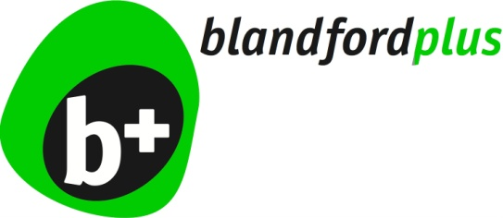 | Pre-Submission Plan Consultation Comment Slip  Consultation Period 7th November – 19th December 2018
Name:
Organisation (If applicable):
Address:
Email:
Your Comments:

